Linear and logist regression analysis

Geiser C. Challco [geiser@alumni.usp.br](mailto:geiser@alumni.usp.br)

Table of Contents

## Initial Variables and Data

dat <- read_excel("../data/API_IT.NET.USER.ZS_DS2_en_excel_v2_4578034.xls", sheet = "Data")  
  
lmdls <- c()  
smdls <- c()  
  
income_grp <- unique(dat$IncomeGroup)  
(income_grp <- income_grp[!is.na(income_grp)])

## [1] "High income" "Low income" "Lower middle income"  
## [4] "Upper middle income"

## Calculating data with mean values

df <- get_data(dat, income_grp[1], is.mean = T)  
for (i in 2:length(income_grp)) {  
 grp = income_grp[i]  
 df <- merge(df, get_data(dat, grp, is.mean = T), by="year", suffixes = c(income_grp[i-1], grp))  
}  
colnames(df) <- c("year",income_grp)  
  
knitr::kable(df)

| year | High income | Low income | Lower middle income | Upper middle income |
| --- | --- | --- | --- | --- |
| 1990 | 0.0671058 | 0.0000000 | 0.0000000 | 0.0000000 |
| 1991 | 0.1454583 | 0.0000000 | 0.0000000 | 0.0004413 |
| 1992 | 0.2647899 | 0.0000000 | 0.0000021 | 0.0015767 |
| 1993 | 0.3964793 | 0.0000000 | 0.0000365 | 0.0071608 |
| 1994 | 0.7911073 | 0.0002561 | 0.0009966 | 0.0219952 |
| 1995 | 1.6969305 | 0.0007982 | 0.0083312 | 0.0757508 |
| 1996 | 3.5315378 | 0.0041361 | 0.0465711 | 0.2512393 |
| 1997 | 6.2714005 | 0.0178438 | 0.1247625 | 0.4874393 |
| 1998 | 10.0863247 | 0.0385727 | 0.2571704 | 1.0589047 |
| 1999 | 15.1978418 | 0.1023982 | 0.4800223 | 1.7148949 |
| 2000 | 21.5348706 | 0.1509140 | 0.9489474 | 3.0918935 |
| 2001 | 26.2811537 | 0.2117980 | 1.3065904 | 4.1840204 |
| 2002 | 32.7128557 | 0.4048750 | 1.8292236 | 6.9248279 |
| 2003 | 37.7003655 | 0.5902493 | 2.5461456 | 8.4695207 |
| 2004 | 42.1865811 | 0.7932204 | 3.5553573 | 11.1434792 |
| 2005 | 45.7616444 | 1.0727464 | 4.5013860 | 12.6559611 |
| 2006 | 49.9984613 | 1.4028515 | 5.5375448 | 14.8918699 |
| 2007 | 54.5409368 | 2.0596837 | 6.7201414 | 17.7988164 |
| 2008 | 58.6774715 | 2.2787529 | 8.3296951 | 20.8653411 |
| 2009 | 62.0247681 | 2.9582266 | 10.0326415 | 24.7143137 |
| 2010 | 65.1609268 | 3.6408000 | 12.7364151 | 28.7954902 |
| 2011 | 67.8698835 | 4.0514346 | 14.7653823 | 32.9868507 |
| 2012 | 71.3689699 | 4.7450198 | 17.0758696 | 37.0258657 |
| 2013 | 74.8227091 | 5.3764525 | 19.5108191 | 40.8245658 |
| 2014 | 77.1314301 | 6.7417683 | 22.8145250 | 44.8462558 |
| 2015 | 79.1694788 | 8.5064896 | 25.8491503 | 49.3817013 |
| 2016 | 81.6434925 | 10.8334244 | 29.4463373 | 53.6443145 |
| 2017 | 83.0251791 | 13.0858931 | 33.4585235 | 58.1722156 |
| 2018 | 85.9626277 | 16.1782617 | 40.6027584 | 64.8826994 |
| 2019 | 87.8712168 | 18.2840909 | 44.6250172 | 67.9207244 |
| 2020 | 89.5181492 | 21.0466667 | 49.1476509 | 72.1393955 |
| 2021 | NaN | NaN | NaN | NaN |

## Linear Regression

### Linear regression for high income countries

grp = income_grp[1]  
dat2 <- get_data(dat, grp)  
  
fit <- lm(IT.NET.USER.ZS ~ year, data=dat2)  
lmdls[[grp]] <- fit  
summary(fit)

##   
## Call:  
## lm(formula = IT.NET.USER.ZS ~ year, data = dat2)  
##   
## Residuals:  
## Min 1Q Median 3Q Max   
## -38.464 -9.904 -0.856 9.171 47.032   
##   
## Coefficients:  
## Estimate Std. Error t value Pr(>|t|)   
## (Intercept) -7.078e+03 6.832e+01 -103.6 <2e-16 ***  
## year 3.552e+00 3.408e-02 104.2 <2e-16 ***  
## ---  
## Signif. codes: 0 '***' 0.001 '**' 0.01 '*' 0.05 '.' 0.1 ' ' 1  
##   
## Residual standard error: 13.94 on 2143 degrees of freedom  
## Multiple R-squared: 0.8352, Adjusted R-squared: 0.8351   
## F-statistic: 1.086e+04 on 1 and 2143 DF, p-value: < 2.2e-16

pyear <- seq(min(dat2$year), max(dat2$year), 1)  
plot(dat2, xlim = c(min(pyear), max(pyear)), ylim = c(0,100),  
 pch=16, col="blue", main = grp, xaxt='n',yaxt='n', cex = 0.5)  
axis(1, at = seq(min(pyear), max(pyear), 1), tck = 1, lty = 4, col = "lightgray", lwd = 0.5)  
axis(2, at = seq(0, 100, 5), tck = 1, lty = 4, col = "lightgray", lwd = 0.5)  
  
matlines(pyear, predict(fit, newdata=list(year=pyear), interval="confidence"), lwd=1)

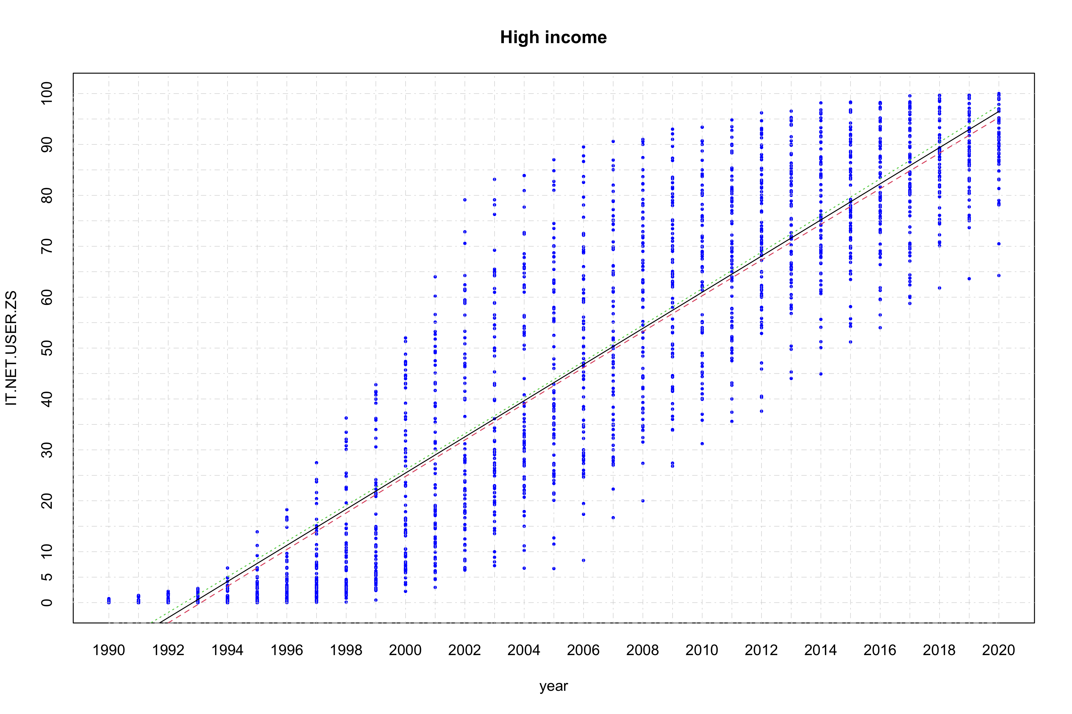

### Linear regression for upper middle income countries

grp = income_grp[4]  
dat2 <- get_data(dat, grp)  
  
fit <- lm(IT.NET.USER.ZS ~ year, data=dat2)  
lmdls[[grp]] <- fit  
summary(fit)

##   
## Call:  
## lm(formula = IT.NET.USER.ZS ~ year, data = dat2)  
##   
## Residuals:  
## Min 1Q Median 3Q Max   
## -31.680 -8.094 -0.092 9.467 36.576   
##   
## Coefficients:  
## Estimate Std. Error t value Pr(>|t|)   
## (Intercept) -4.785e+03 7.244e+01 -66.06 <2e-16 ***  
## year 2.397e+00 3.613e-02 66.35 <2e-16 ***  
## ---  
## Signif. codes: 0 '***' 0.001 '**' 0.01 '*' 0.05 '.' 0.1 ' ' 1  
##   
## Residual standard error: 12.37 on 1502 degrees of freedom  
## Multiple R-squared: 0.7456, Adjusted R-squared: 0.7454   
## F-statistic: 4402 on 1 and 1502 DF, p-value: < 2.2e-16

pyear <- seq(min(dat2$year), 2040, 1)  
plot(dat2, xlim = c(min(pyear), max(pyear)), ylim = c(0,100),  
 pch=16, col="blue", main = grp, xaxt='n',yaxt='n', cex = 0.5)  
axis(1, at = seq(min(pyear), max(pyear), 1), tck = 1, lty = 4, col = "lightgray", lwd = 0.5)  
axis(2, at = seq(0, 100, 5), tck = 1, lty = 4, col = "lightgray", lwd = 0.5)  
  
matlines(pyear, predict(fit, newdata=list(year=pyear), interval="confidence"), lwd=1)

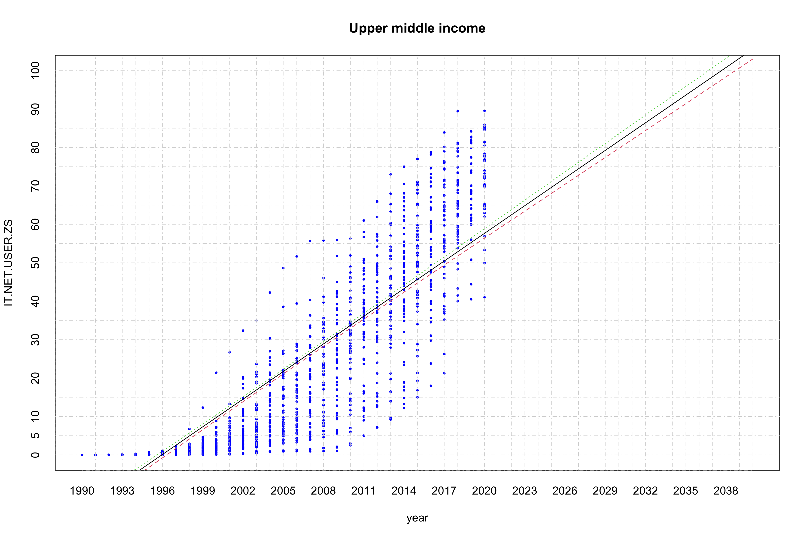

### Linear regression for lower middle income countries

grp = income_grp[3]  
dat2 <- get_data(dat, grp)  
  
fit <- lm(IT.NET.USER.ZS ~ year, data=dat2)  
lmdls[[grp]] <- fit  
summary(fit)

##   
## Call:  
## lm(formula = IT.NET.USER.ZS ~ year, data = dat2)  
##   
## Residuals:  
## Min 1Q Median 3Q Max   
## -20.566 -7.260 -1.532 5.408 52.033   
##   
## Coefficients:  
## Estimate Std. Error t value Pr(>|t|)   
## (Intercept) -2.773e+03 6.312e+01 -43.94 <2e-16 ***  
## year 1.389e+00 3.148e-02 44.11 <2e-16 ***  
## ---  
## Signif. codes: 0 '***' 0.001 '**' 0.01 '*' 0.05 '.' 0.1 ' ' 1  
##   
## Residual standard error: 11.13 on 1593 degrees of freedom  
## Multiple R-squared: 0.5498, Adjusted R-squared: 0.5496   
## F-statistic: 1946 on 1 and 1593 DF, p-value: < 2.2e-16

pyear <- seq(min(dat2$year), 2070, 1)  
plot(dat2, xlim = c(min(pyear), max(pyear)), ylim = c(0,100),  
 pch=16, col="blue", main = grp, xaxt='n',yaxt='n', cex = 0.75)  
axis(1, at = seq(min(pyear), max(pyear), 5), tck = 1, lty = 4, col = "lightgray", lwd = 0.75)  
axis(2, at = seq(0, 100, 5), tck = 1, lty = 4, col = "lightgray", lwd = 0.75)  
  
matlines(pyear, predict(fit, newdata=list(year=pyear), interval="confidence"), lwd=1.25)

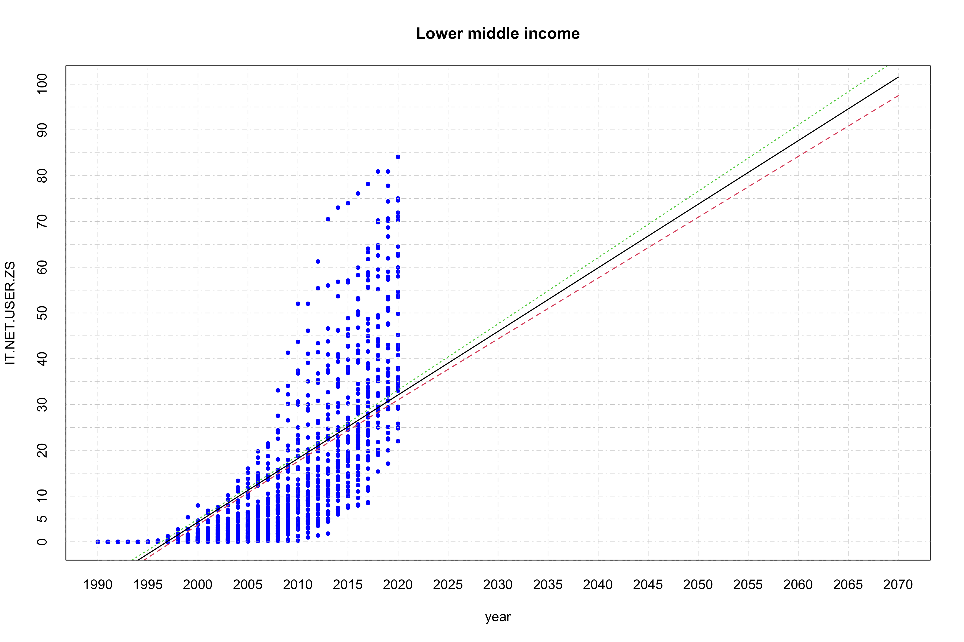

### Linear regression for low income countries

grp = income_grp[2]  
dat2 <- get_data(dat, grp)  
  
fit <- lm(IT.NET.USER.ZS ~ year, data=dat2)  
lmdls[[grp]] <- fit  
summary(fit)

##   
## Call:  
## lm(formula = IT.NET.USER.ZS ~ year, data = dat2)  
##   
## Residuals:  
## Min 1Q Median 3Q Max   
## -8.8467 -3.3289 -0.8389 2.2925 24.7884   
##   
## Coefficients:  
## Estimate Std. Error t value Pr(>|t|)   
## (Intercept) -1.036e+03 4.102e+01 -25.25 <2e-16 ***  
## year 5.187e-01 2.046e-02 25.35 <2e-16 ***  
## ---  
## Signif. codes: 0 '***' 0.001 '**' 0.01 '*' 0.05 '.' 0.1 ' ' 1  
##   
## Residual standard error: 5.132 on 794 degrees of freedom  
## Multiple R-squared: 0.4472, Adjusted R-squared: 0.4465   
## F-statistic: 642.4 on 1 and 794 DF, p-value: < 2.2e-16

pyear <- seq(min(dat2$year), 2190, 1)  
plot(dat2, xlim = c(min(pyear), max(pyear)), ylim = c(0,100),  
 pch=16, col="blue", main = grp, xaxt='n',yaxt='n', cex = 0.75)  
axis(1, at = seq(min(pyear), max(pyear), 5), tck = 1, lty = 4, col = "lightgray", lwd = 0.75)  
axis(2, at = seq(0, 100, 5), tck = 1, lty = 4, col = "lightgray", lwd = 0.75)  
  
matlines(pyear, predict(fit, newdata=list(year=pyear), interval="confidence"), lwd=1.25)

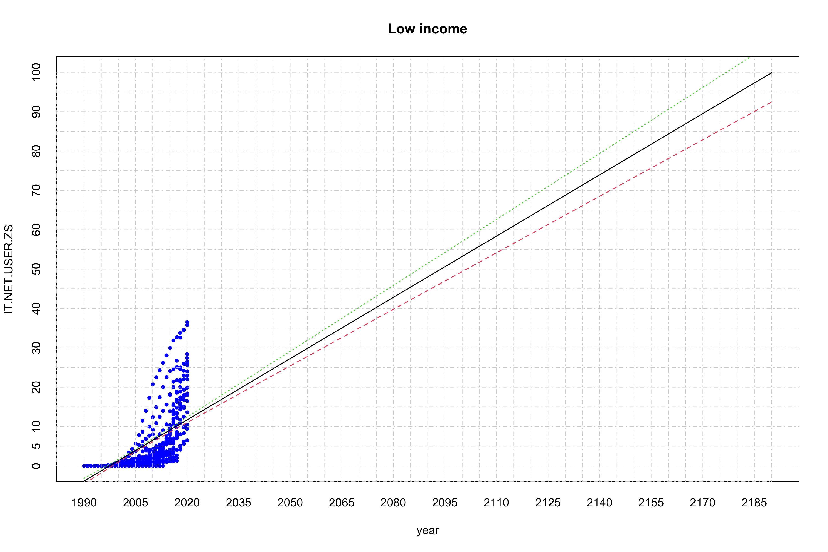

### Summary of linear regression with average values

pyear <- seq(1990, 2190, 1)  
plot(x=pyear, y=c(), xlim = c(min(pyear), max(pyear)), ylim=c(0,100),  
 ylab = "IT.NET.USER.ZS", xlab = "year", xaxt='n',yaxt='n')  
axis(1, at = seq(min(pyear),max(pyear), 5), tck = 1, lty = 4, col = "lightgray", lwd = 0.75)  
axis(2, at = seq(0, 100, 5), tck = 1, lty = 4, col = "lightgray", lwd = 0.75)  
  
colors <- c("blue","red","orange","green")  
names(colors) <- income_grp  
for (grp in income_grp) {  
 gdat <- get_data(dat, grp, is.mean = T)  
 points(x=gdat$year, y=gdat$IT.NET.USER.ZS, pch=16, col=colors[grp], xaxt='n', yaxt='n', cex=0.75)  
 matlines(pyear, predict(lmdls[[grp]], newdata=list(year=pyear), interval="confidence"), lwd=1)  
}  
legend("bottomright", legend=c("high income","low income","lower middle income","upper middle income"),  
 col=colors, lty=0, cex = 0.75, bg = "transparent", pch=16, box.lty=0)

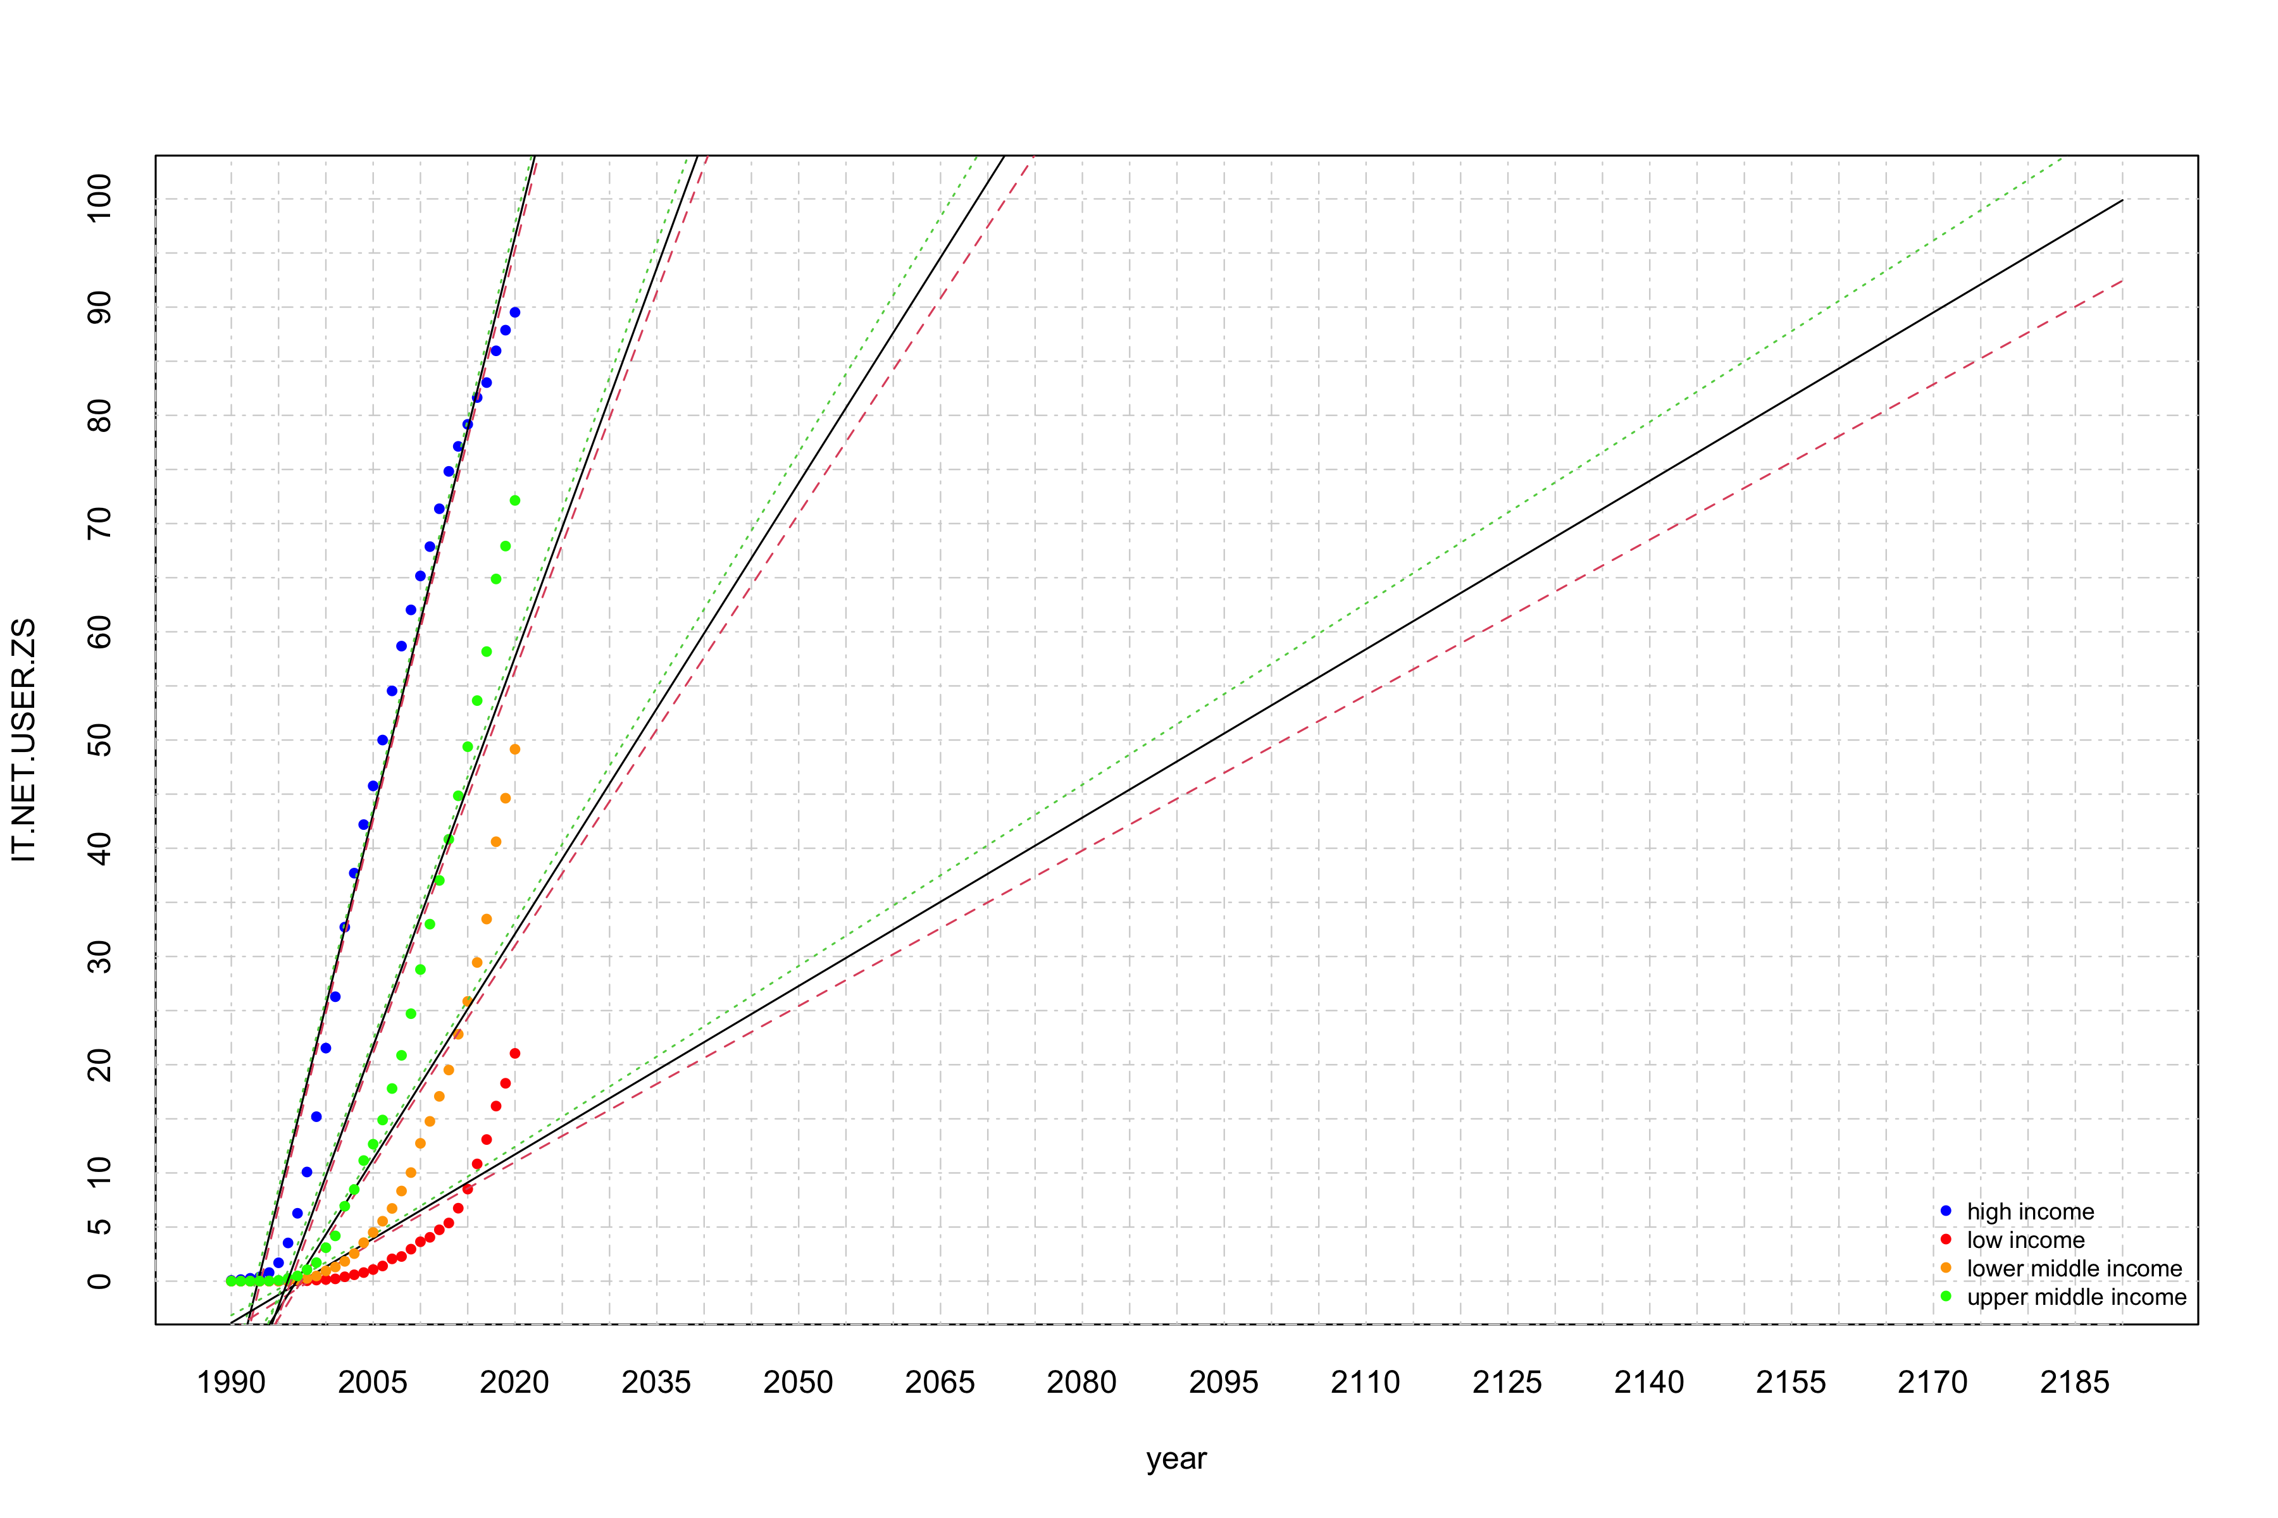

pyear <- seq(1990, 2190, 1)  
plot(x=pyear, y=c(), xlim = c(min(pyear), max(pyear)), ylim=c(0,100),  
 ylab = "IT.NET.USER.ZS", xlab = "year", xaxt='n',yaxt='n')  
axis(1, at = seq(min(pyear),max(pyear), 5), tck = 1, lty = 4, col = "lightgray", lwd = 0.75)  
axis(2, at = seq(0, 100, 5), tck = 1, lty = 4, col = "lightgray", lwd = 0.75)  
  
colors <- c("blue","red","orange","green")  
names(colors) <- income_grp  
for (grp in income_grp) {  
 gdat <- get_data(dat, grp, is.mean = F)  
 points(x=gdat$year, y=gdat$IT.NET.USER.ZS, pch=16, col=colors[grp], xaxt='n', yaxt='n', cex=0.75)  
 matlines(pyear, predict(lmdls[[grp]], newdata=list(year=pyear), interval="confidence"), lwd=1)  
}  
legend("bottomright", legend=c("high income","low income","lower middle income","upper middle income"),  
 col=colors, lty=0, cex = 0.75, bg = "transparent", pch=16, box.lty=0)

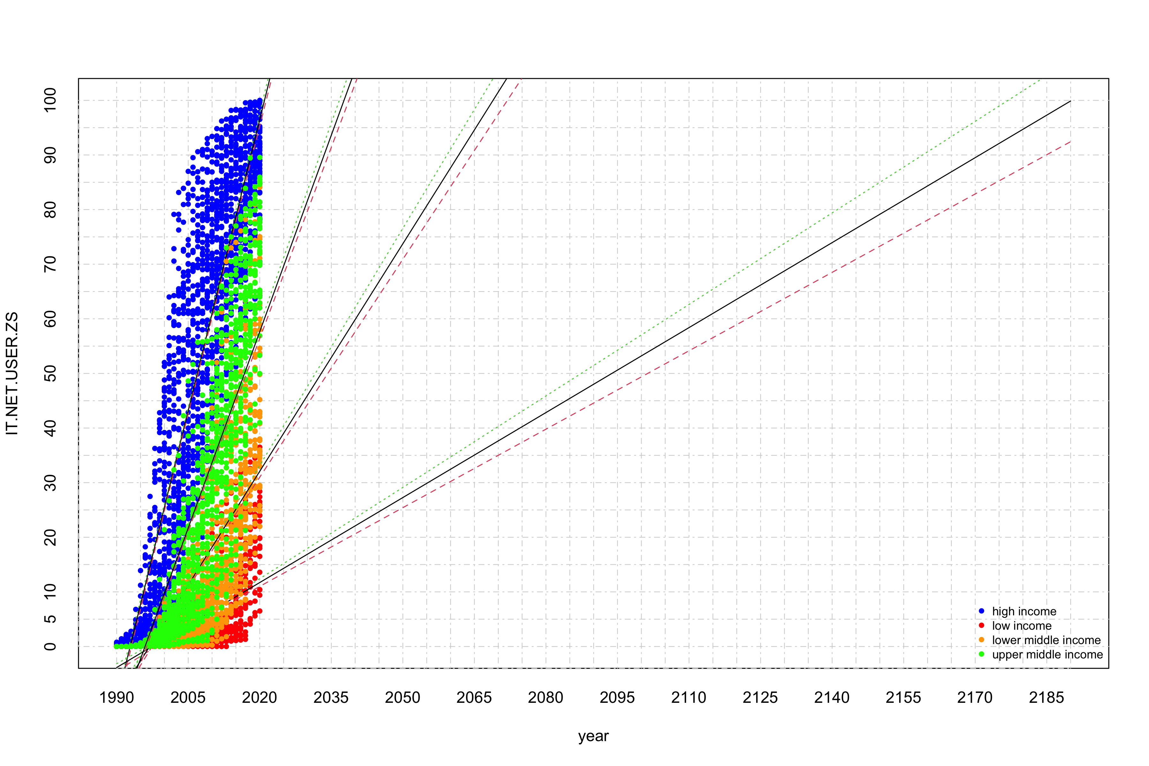

## Logistic Regression

### Logistic regression for high income countries

grp = income_grp[1]  
dat2 <- get_data(dat, grp)  
  
fit <- nls(IT.NET.USER.ZS ~ SSlogis(year, Asym, xmid, scal), data=dat2)  
smdls[[grp]] <- fit  
summary(fit)

##   
## Formula: IT.NET.USER.ZS ~ SSlogis(year, Asym, xmid, scal)  
##   
## Parameters:  
## Estimate Std. Error t value Pr(>|t|)   
## Asym 85.8351 0.9320 92.10 <2e-16 ***  
## xmid 2004.7754 0.1508 13291.23 <2e-16 ***  
## scal 3.8719 0.1144 33.84 <2e-16 ***  
## ---  
## Signif. codes: 0 '***' 0.001 '**' 0.01 '*' 0.05 '.' 0.1 ' ' 1  
##   
## Residual standard error: 13.44 on 2142 degrees of freedom  
##   
## Number of iterations to convergence: 4   
## Achieved convergence tolerance: 8.016e-06

Asym = fit$m$getAllPars()["Asym"]  
xmid = fit$m$getAllPars()["xmid"]  
scal = fit$m$getAllPars()["scal"]  
  
(min(dat2$year)+(xmid-min(dat2$year))*100/Asym)

## xmid   
## 2007.214

fit <- nls(IT.NET.USER.ZS ~ 100/(1+exp(-1*(year-2007.214)/scal)), data = dat2, start = list(scal=scal))  
smdls[[grp]] <- fit  
summary(fit)

##   
## Formula: IT.NET.USER.ZS ~ 100/(1 + exp(-1 * (year - 2007.214)/scal))  
##   
## Parameters:  
## Estimate Std. Error t value Pr(>|t|)   
## scal 5.15269 0.08881 58.02 <2e-16 ***  
## ---  
## Signif. codes: 0 '***' 0.001 '**' 0.01 '*' 0.05 '.' 0.1 ' ' 1  
##   
## Residual standard error: 13.86 on 2144 degrees of freedom  
##   
## Number of iterations to convergence: 4   
## Achieved convergence tolerance: 4.171e-06

pyear <- seq(max(dat2$year), max(dat2$year)+35, 1)  
myear <- min(pyear)+sum(predict(fit, newdata=list(year=pyear)) < 99.5)  
pyear <- seq(myear-2,myear+2, 1)  
df <- predict(fit, newdata=list(year=pyear), interval = "confidence")  
names(df) <- pyear  
(df)

## 2033 2034 2035 2036 2037   
## 99.33362 99.45052 99.54701 99.62662 99.69229

pyear <- seq(min(dat2$year), 2036, 1)  
plot(dat2, xlim = c(min(pyear), max(pyear)), ylim = c(0,100),  
 pch=16, col="blue", main = grp, xaxt='n',yaxt='n', cex = 0.5)  
axis(1, at = seq(min(pyear), max(pyear), 2), tck = 1, lty = 4, col = "lightgray", lwd = 0.75)  
axis(2, at = seq(0, 100, 5), tck = 1, lty = 4, col = "lightgray", lwd = 0.75)  
  
matlines(pyear, predict(fit, newdata=list(year=pyear), interval="confidence"), lwd=1.25)

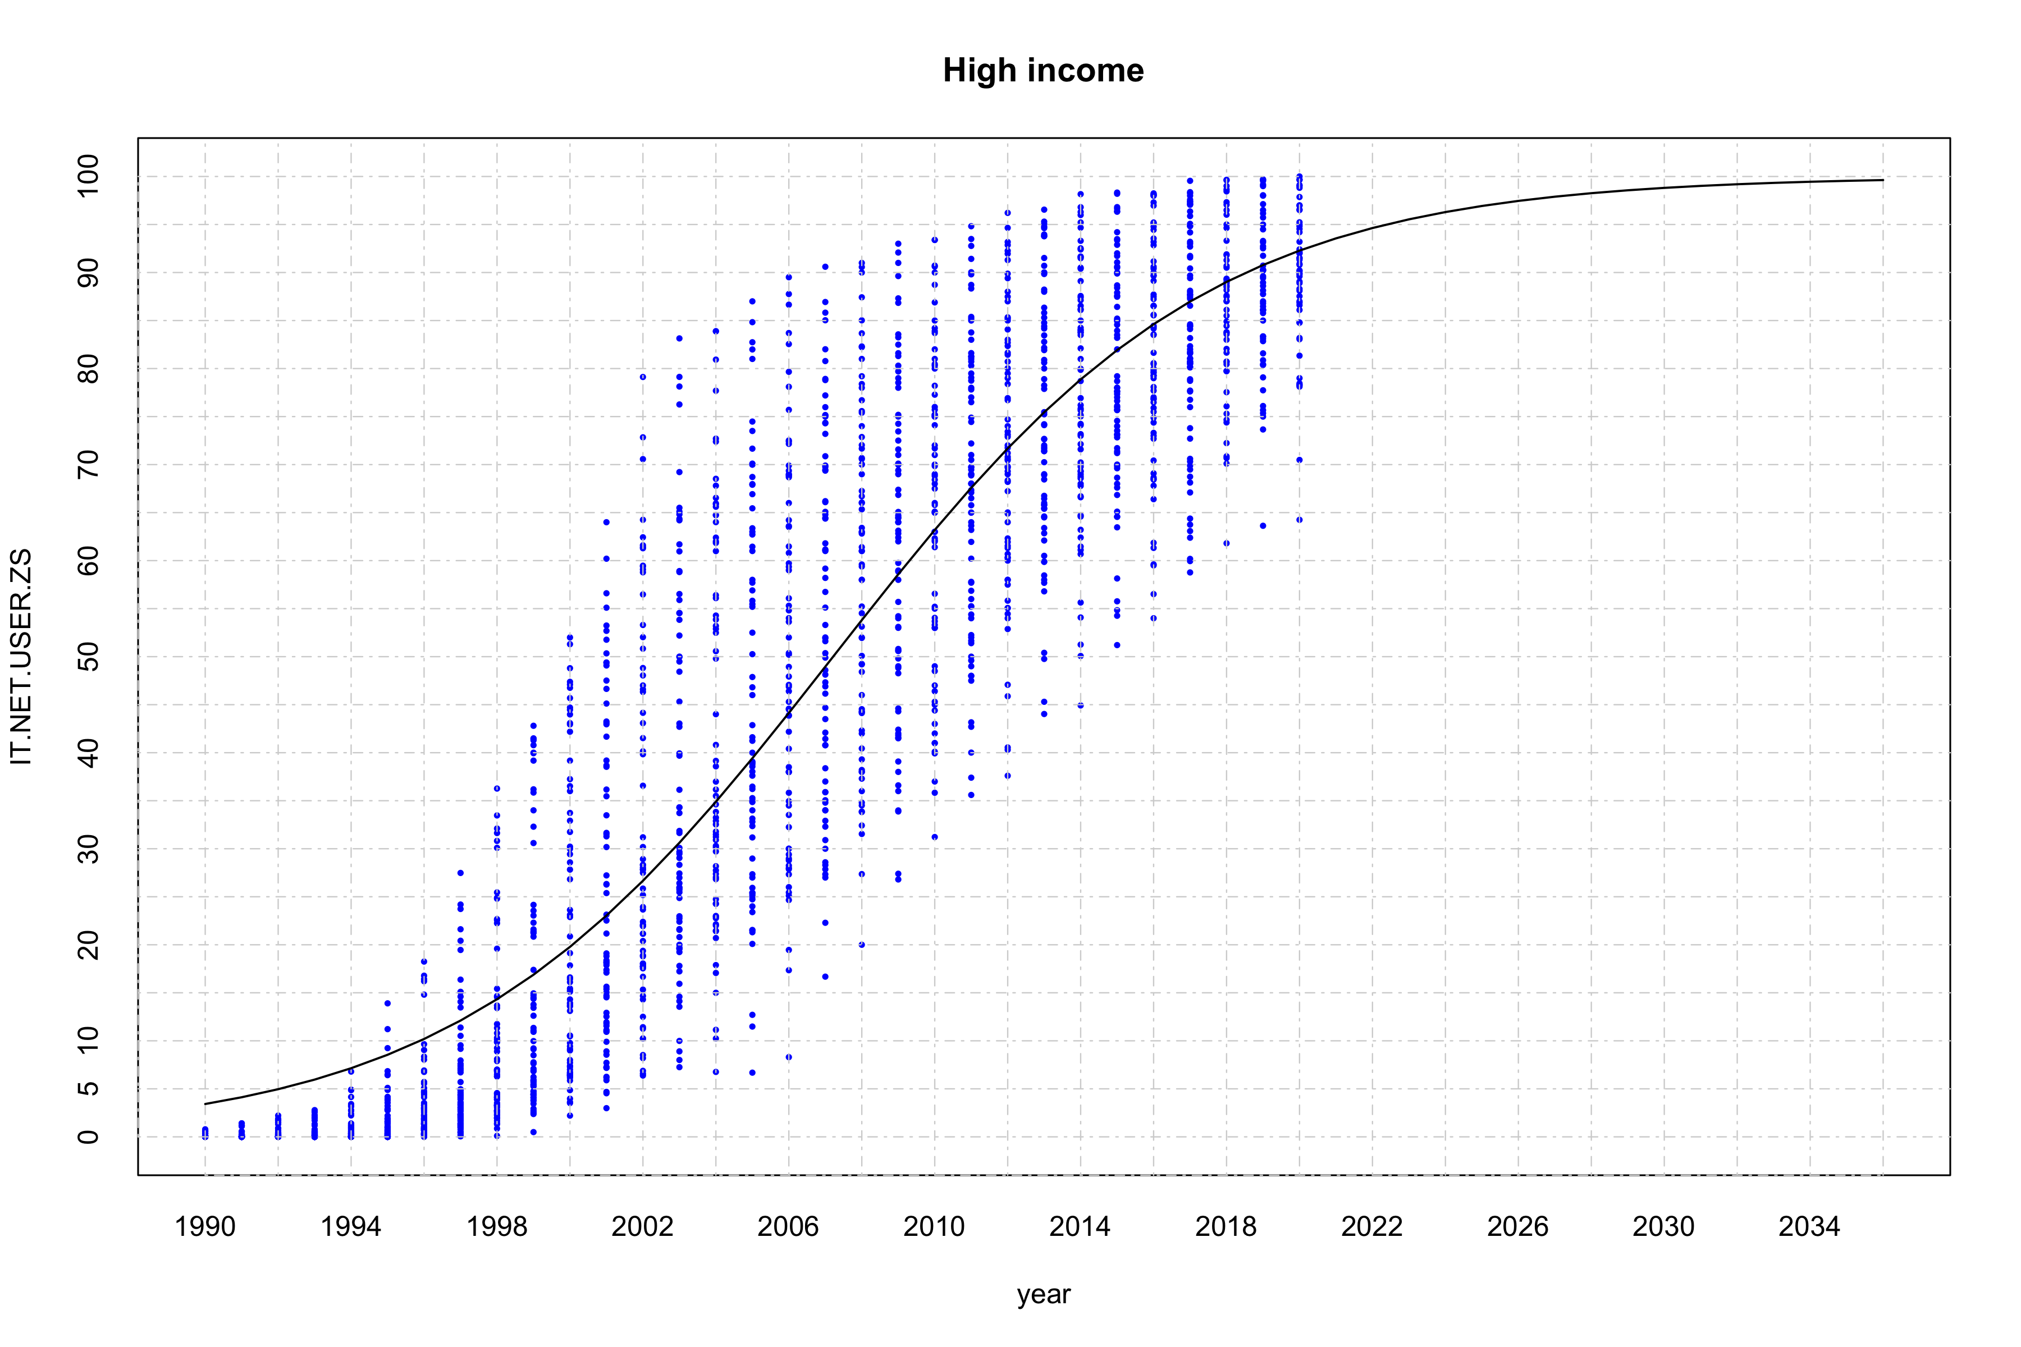

### Logistic regression for upper middle income countries

grp = income_grp[4]  
dat2 <- get_data(dat, grp)  
  
fit <- nls(IT.NET.USER.ZS ~ SSlogis(year, Asym, xmid, scal), data=dat2)  
smdls[[grp]] <- fit  
summary(fit)

##   
## Formula: IT.NET.USER.ZS ~ SSlogis(year, Asym, xmid, scal)  
##   
## Parameters:  
## Estimate Std. Error t value Pr(>|t|)   
## Asym 88.4304 3.8442 23.00 <2e-16 ***  
## xmid 2013.6320 0.4798 4196.40 <2e-16 ***  
## scal 4.6477 0.1970 23.59 <2e-16 ***  
## ---  
## Signif. codes: 0 '***' 0.001 '**' 0.01 '*' 0.05 '.' 0.1 ' ' 1  
##   
## Residual standard error: 9.794 on 1501 degrees of freedom  
##   
## Number of iterations to convergence: 3   
## Achieved convergence tolerance: 5.134e-06

Asym = fit$m$getAllPars()["Asym"]  
xmid = fit$m$getAllPars()["xmid"]  
scal = fit$m$getAllPars()["scal"]  
  
(min(dat2$year)+(xmid-min(dat2$year))*100/Asym)

## xmid   
## 2016.724

fit <- nls(IT.NET.USER.ZS ~ 100/(1+exp(-1*(year-2016.724)/scal)), data = dat2, start = list(scal=scal))  
smdls[[grp]] <- fit  
summary(fit)

##   
## Formula: IT.NET.USER.ZS ~ 100/(1 + exp(-1 * (year - 2016.724)/scal))  
##   
## Parameters:  
## Estimate Std. Error t value Pr(>|t|)   
## scal 6.1277 0.1131 54.19 <2e-16 ***  
## ---  
## Signif. codes: 0 '***' 0.001 '**' 0.01 '*' 0.05 '.' 0.1 ' ' 1  
##   
## Residual standard error: 10.64 on 1503 degrees of freedom  
##   
## Number of iterations to convergence: 5   
## Achieved convergence tolerance: 3.716e-06

pyear <- seq(max(dat2$year), max(dat2$year)+50, 1)  
myear <- min(pyear)+sum(predict(fit, newdata=list(year=pyear)) < 99.5)  
pyear <- seq(myear-2,myear+2, 1)  
df <- predict(fit, newdata=list(year=pyear), interval = "confidence")  
names(df) <- pyear  
(df)

## 2048 2049 2050 2051 2052   
## 99.39647 99.48688 99.56380 99.62924 99.68489

pyear <- seq(min(dat2$year), 2050, 1)  
plot(dat2, xlim = c(min(pyear), max(pyear)), ylim = c(0,100),  
 pch=16, col="blue", main = grp, xaxt='n',yaxt='n', cex = 0.5)  
axis(1, at = seq(min(pyear), max(pyear), 4), tck = 1, lty = 4, col = "lightgray", lwd = 0.75)  
axis(2, at = seq(0, 100, 5), tck = 1, lty = 4, col = "lightgray", lwd = 0.75)  
  
matlines(pyear, predict(fit, newdata=list(year=pyear), interval="confidence"), lwd=1.25)

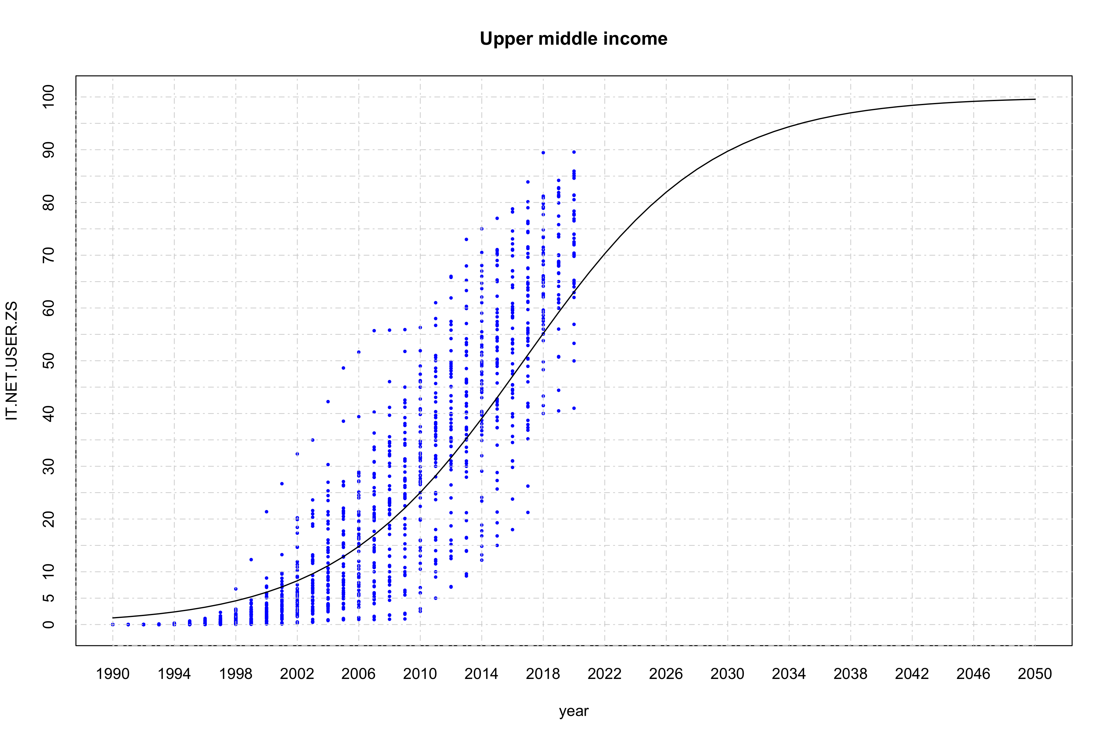

### Logistic regression for lower middle income countries

grp = income_grp[3]  
dat2 <- get_data(dat, grp)  
  
fit <- nls(IT.NET.USER.ZS ~ SSlogis(year, Asym, xmid, scal), data=dat2)  
smdls[[grp]] <- fit  
summary(fit)

##   
## Formula: IT.NET.USER.ZS ~ SSlogis(year, Asym, xmid, scal)  
##   
## Parameters:  
## Estimate Std. Error t value Pr(>|t|)   
## Asym 92.8126 15.1584 6.123 1.16e-09 ***  
## xmid 2019.4656 1.4861 1358.932 < 2e-16 ***  
## scal 4.8565 0.3338 14.551 < 2e-16 ***  
## ---  
## Signif. codes: 0 '***' 0.001 '**' 0.01 '*' 0.05 '.' 0.1 ' ' 1  
##   
## Residual standard error: 9.068 on 1592 degrees of freedom  
##   
## Number of iterations to convergence: 3   
## Achieved convergence tolerance: 3.66e-06

Asym = fit$m$getAllPars()["Asym"]  
xmid = fit$m$getAllPars()["xmid"]  
scal = fit$m$getAllPars()["scal"]  
  
(min(dat2$year)+(xmid-min(dat2$year))*100/Asym)

## xmid   
## 2021.747

fit <- nls(IT.NET.USER.ZS ~ 100/(1+exp(-1*(year-2021.747)/scal)), data = dat2, start = list(scal=scal))  
smdls[[grp]] <- fit  
summary(fit)

##   
## Formula: IT.NET.USER.ZS ~ 100/(1 + exp(-1 * (year - 2021.747)/scal))  
##   
## Parameters:  
## Estimate Std. Error t value Pr(>|t|)   
## scal 6.07748 0.09645 63.01 <2e-16 ***  
## ---  
## Signif. codes: 0 '***' 0.001 '**' 0.01 '*' 0.05 '.' 0.1 ' ' 1  
##   
## Residual standard error: 9.277 on 1594 degrees of freedom  
##   
## Number of iterations to convergence: 5   
## Achieved convergence tolerance: 2.678e-06

pyear <- seq(max(dat2$year), max(dat2$year)+150, 1)  
myear <- min(pyear)+sum(predict(fit, newdata=list(year=pyear)) < 99.5)  
pyear <- seq(myear-2,myear+2, 1)  
df <- predict(fit, newdata=list(year=pyear), interval = "confidence")  
names(df) <- pyear  
(df)

## 2052 2053 2054 2055 2056   
## 99.31585 99.41905 99.50675 99.58127 99.64458

pyear <- seq(min(dat2$year), 2058, 1)  
plot(dat2, xlim = c(min(pyear), max(pyear)), ylim = c(0,100),  
 pch=16, col="blue", main = grp, xaxt='n',yaxt='n', cex = 0.5)  
axis(1, at = seq(min(pyear), max(pyear), 4), tck = 1, lty = 4, col = "lightgray", lwd = 0.75)  
axis(2, at = seq(0, 100, 5), tck = 1, lty = 4, col = "lightgray", lwd = 0.75)  
  
matlines(pyear, predict(fit, newdata=list(year=pyear), interval="confidence"), lwd=1.25)

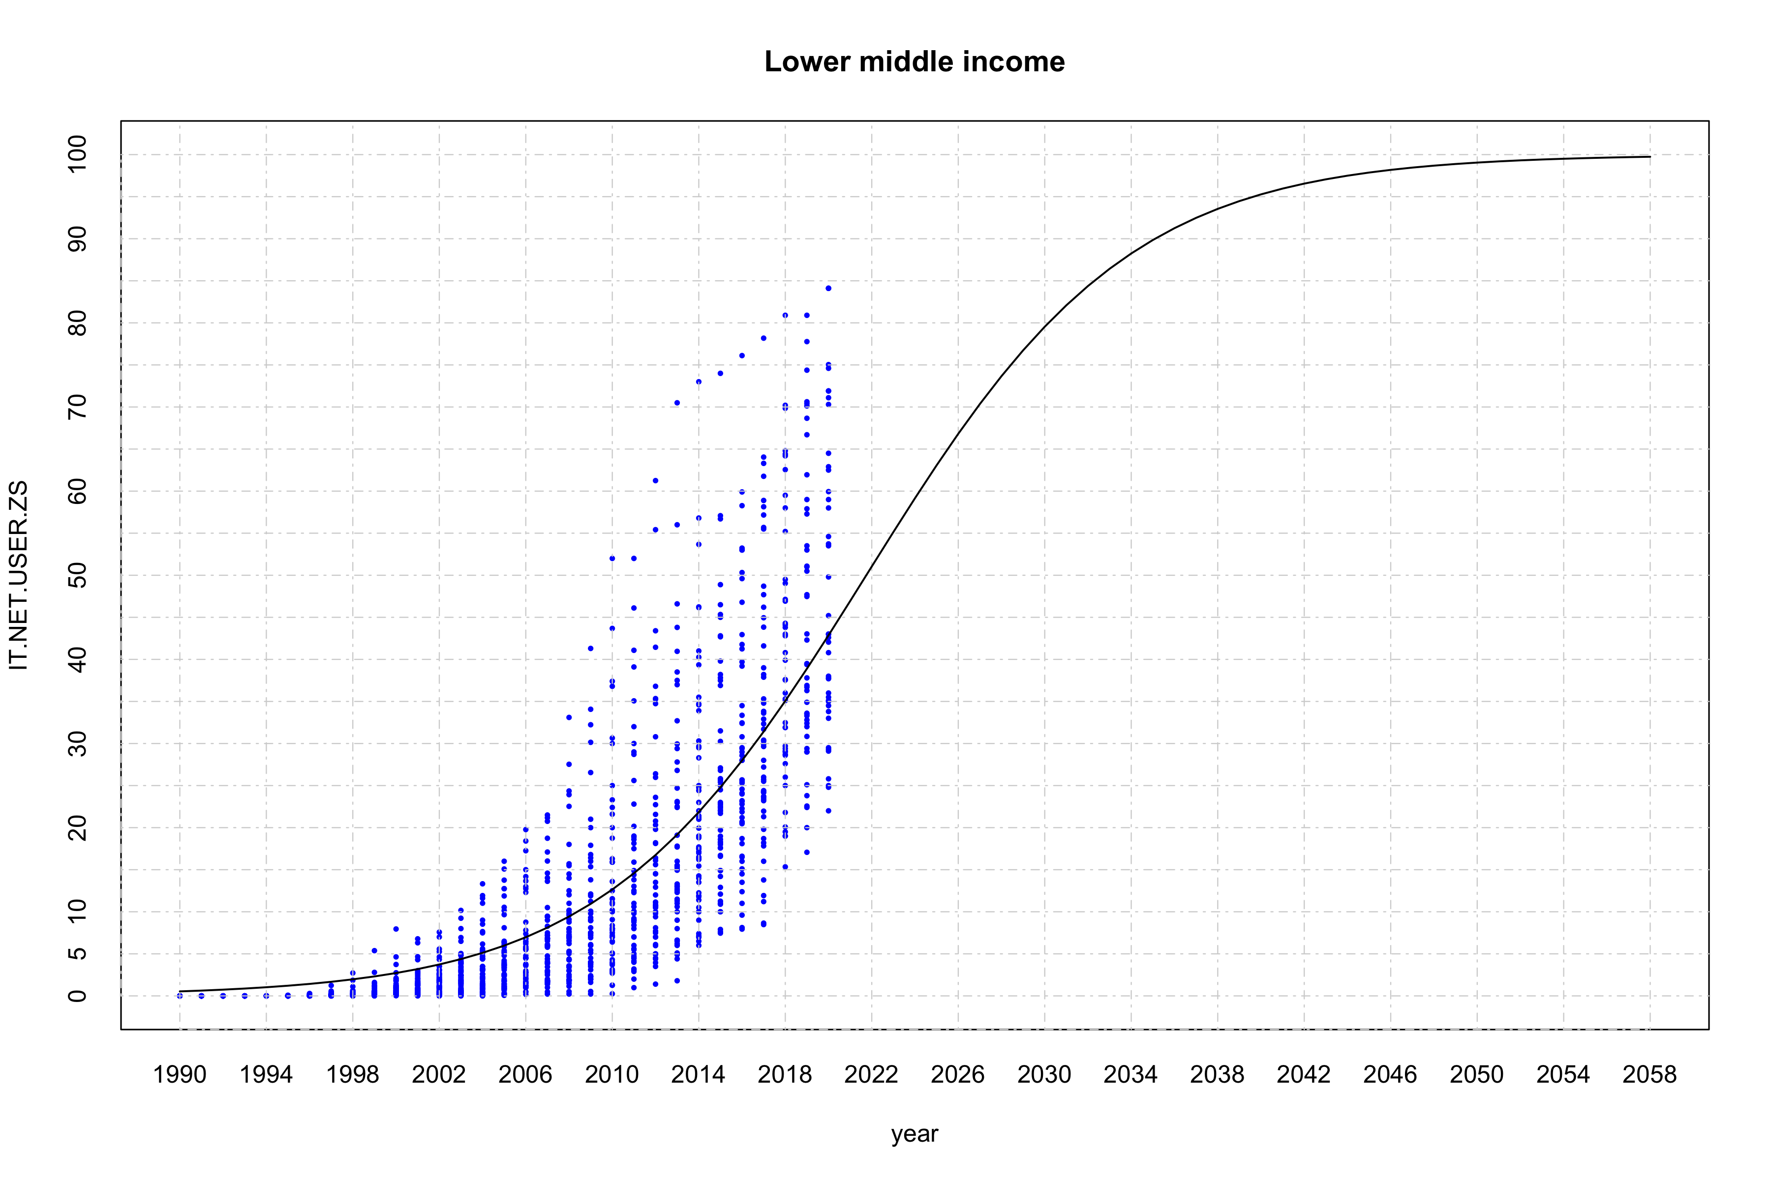

### Logistic regression for low income countries

grp = income_grp[2]  
dat2 <- get_data(dat, grp)  
  
fit <- nls(IT.NET.USER.ZS ~ SSlogis(year, Asym, xmid, scal), data=dat2)  
smdls[[grp]] <- fit  
summary(fit)

##   
## Formula: IT.NET.USER.ZS ~ SSlogis(year, Asym, xmid, scal)  
##   
## Parameters:  
## Estimate Std. Error t value Pr(>|t|)   
## Asym 63.6779 34.4079 1.851 0.0646 .   
## xmid 2023.0045 3.7704 536.554 < 2e-16 ***  
## scal 4.3987 0.5267 8.351 3.01e-16 ***  
## ---  
## Signif. codes: 0 '***' 0.001 '**' 0.01 '*' 0.05 '.' 0.1 ' ' 1  
##   
## Residual standard error: 4.084 on 793 degrees of freedom  
##   
## Number of iterations to convergence: 3   
## Achieved convergence tolerance: 8.246e-07

Asym = fit$m$getAllPars()["Asym"]  
xmid = fit$m$getAllPars()["xmid"]  
scal = fit$m$getAllPars()["scal"]  
  
(min(dat2$year)+(xmid-min(dat2$year))*100/Asym)

## xmid   
## 2041.83

fit <- nls(IT.NET.USER.ZS ~ 100/(1+exp(-1*(year-2041.83)/scal)), data = dat2, start = list(scal=scal))  
smdls[[grp]] <- fit  
summary(fit)

##   
## Formula: IT.NET.USER.ZS ~ 100/(1 + exp(-1 * (year - 2041.83)/scal))  
##   
## Parameters:  
## Estimate Std. Error t value Pr(>|t|)   
## scal 11.1687 0.1501 74.42 <2e-16 ***  
## ---  
## Signif. codes: 0 '***' 0.001 '**' 0.01 '*' 0.05 '.' 0.1 ' ' 1  
##   
## Residual standard error: 4.914 on 795 degrees of freedom  
##   
## Number of iterations to convergence: 6   
## Achieved convergence tolerance: 1.684e-06

pyear <- seq(max(dat2$year), max(dat2$year)+150, 1)  
myear <- min(pyear)+sum(predict(fit, newdata=list(year=pyear)) < 99.5)  
pyear <- seq(myear-2,myear+2, 1)  
df <- predict(fit, newdata=list(year=pyear), interval = "confidence")  
names(df) <- pyear  
(df)

## 2099 2100 2101 2102 2103   
## 99.40522 99.45588 99.50225 99.54468 99.58352

pyear <- seq(min(dat2$year), 2100, 1)  
plot(dat2, xlim = c(min(pyear), max(pyear)), ylim = c(0,100),  
 pch=16, col="blue", main = grp, xaxt='n',yaxt='n', cex = 0.5)  
axis(1, at = seq(min(pyear), max(pyear), 5), tck = 1, lty = 4, col = "lightgray", lwd = 0.75)  
axis(2, at = seq(0, 100, 5), tck = 1, lty = 4, col = "lightgray", lwd = 0.75)  
  
matlines(pyear, predict(fit, newdata=list(year=pyear), interval="confidence"), lwd=1.25)

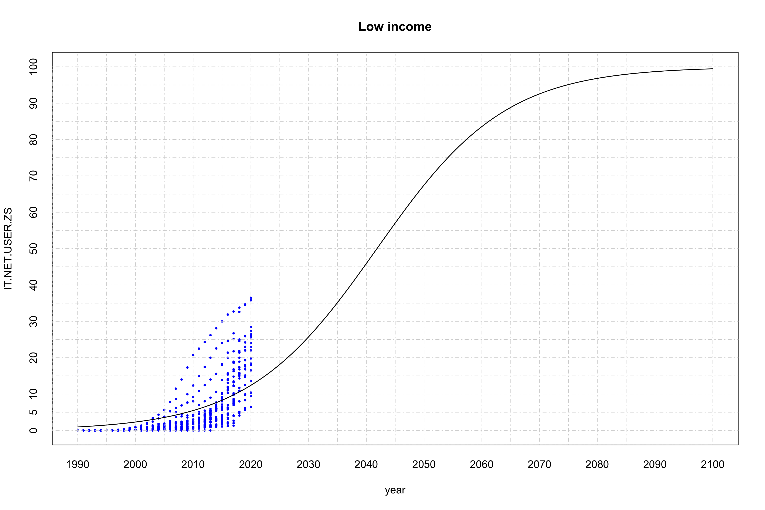

### Summary of logistic regression with average values

pyear <- seq(1990, 2100, 1)  
plot(x=pyear, y=c(), xlim = c(min(pyear), max(pyear)), ylim=c(0,100),  
 ylab = "IT.NET.USER.ZS", xlab = "year", xaxt='n',yaxt='n')  
axis(1, at = seq(min(pyear),max(pyear), 5), tck = 1, lty = 4, col = "lightgray", lwd = 0.75)  
axis(2, at = seq(0, 100, 5), tck = 1, lty = 4, col = "lightgray", lwd = 0.75)  
  
colors <- c("blue","red","orange","green")  
names(colors) <- income_grp  
for (grp in income_grp) {  
 gdat <- get_data(dat, grp, is.mean = T)  
 points(x=gdat$year, y=gdat$IT.NET.USER.ZS, pch=16, col=colors[grp], xaxt='n', yaxt='n', cex=0.75)  
 matlines(pyear, predict(smdls[[grp]], newdata=list(year=pyear), interval="confidence"), lwd=1)  
}  
legend("bottomright", legend=c("high income","low income","lower middle income","upper middle income"),  
 col=colors, lty=0, cex = 0.75, bg = "transparent", pch=16, box.lty=0)

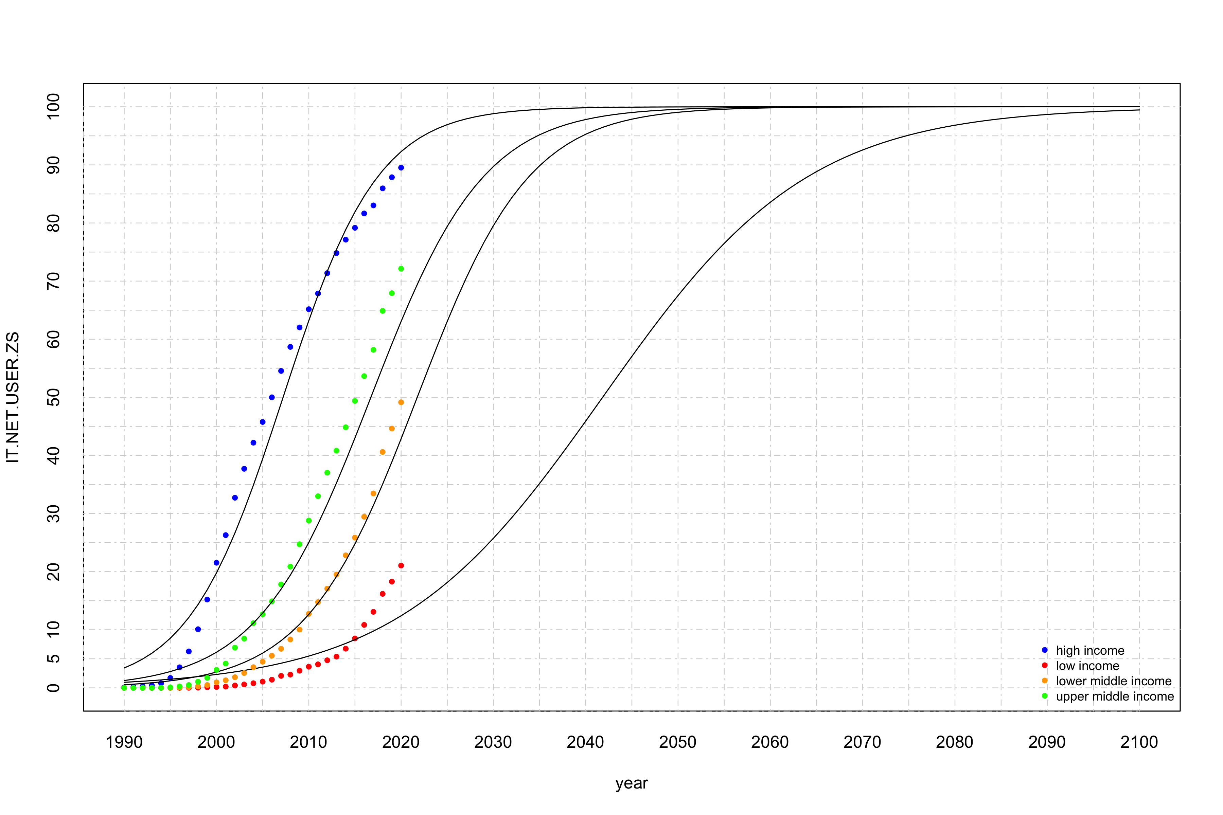

pyear <- seq(1990, 2100, 1)  
plot(x=pyear, y=c(), xlim = c(min(pyear), max(pyear)), ylim=c(0,100),  
 ylab = "IT.NET.USER.ZS", xlab = "year", xaxt='n',yaxt='n')  
axis(1, at = seq(min(pyear),max(pyear), 5), tck = 1, lty = 4, col = "lightgray", lwd = 0.75)  
axis(2, at = seq(0, 100, 5), tck = 1, lty = 4, col = "lightgray", lwd = 0.75)  
  
colors <- c("blue","red","orange","green")  
names(colors) <- income_grp  
for (grp in income_grp) {  
 gdat <- get_data(dat, grp, is.mean = F)  
 points(x=gdat$year, y=gdat$IT.NET.USER.ZS, pch=16, col=colors[grp], xaxt='n', yaxt='n', cex=0.25)  
 matlines(pyear, predict(smdls[[grp]], newdata=list(year=pyear), interval="confidence"), lwd=1)  
}  
legend("bottomright", legend=c("high income","low income","lower middle income","upper middle income"),  
 col=colors, lty=0, cex = 0.75, bg = "transparent", pch=16, box.lty=0)

